Indian Railways Analysis
  - Project report
Python data preparation | MySQL analysis | Power BI reporting
Prepared on 9 October 2026

Executive summary
This project examines train listings, station coverage, recorded schedule entries, and operating day labels to support a railway planning team. The workflow connects two CSV datasets through Train_No, prepares them in Python, loads them into MySQL, and presents a Power BI dashboard.
The datasets contain 11,113 distinct trains and 186,074 station entries across 8,147 station codes. Every train number appears in both datasets. CST-MUMBAI has the greatest number of distinct trains in the schedule, at 1,027. Train 53041 has the most recorded station entries, at 118.
The main reporting improvement is to use stable identifiers and explicit counting rules. Train names are not unique, and station-name counts differ from station-code counts. The dashboard chart labelled as the five trains with the most station entries groups train names from the train master, so it does not answer the stated schedule-entry question.
Verified measure | Result
Distinct train numbers | 11,113
Schedule entries | 186,074
Distinct station codes | 8,147
Trains with schedules | 11,113 | 100% of train master
Unmatched train numbers in either direction | 0
Mean station entries per train | 16.74

Scope of conclusions
These are descriptive results for the project dataset. Schedule records do not establish actual train movements, punctuality, passenger demand, occupancy, or revenue. Operating day labels describe the supplied records and should not be treated as complete weekly service frequencies.

Project objectives and data design

Business objectives
Measure the number of listed trains and stations, identify stations served by many trains, compare recorded station entries by train, summarize source and destination patterns, and detect missing or inconsistent records. The practice brief defines these objectives without operational performance targets.
Project file | Purpose
train_info.csv | Train master with 11,113 rows and 5 columns
train_schedule.csv | Schedule dataset with 186,074 rows and 12 columns
indian_railway.ipynb | Data inspection, transformations, and MySQL loading
SqlAnalysis.sql | KPI queries and 10 analysis questions
Visualization.pbix | Editable Power BI report
Dashboard.pdf | Static dashboard export
Railway_Analytics_Practice.docx | Business problem and practice requirements

Train master fields
Train_No identifies the train; Train_Name supplies its display name. Source_Station_Name and Destination_Station_Name describe its endpoints. The days field contains one day label per train in this dataset. Train_No is unique across all 11,113 records, while the raw Train_Name field has only 7,580 distinct values.

Schedule fields
Train_No links each entry to the master. Station_Code and Station_Name describe the station. SN and Route_Number support schedule ordering and route grouping. Arrival_time and Departure_Time contain clock times. Distance and the class columns 1A, 2A, 3A, and SL are present, but their business meaning and units require confirmation before use as measures.

Recommended relationship
Use a one-to-many relationship from train_info.Train_No to train_schedule.Train_No, with filters flowing from the master to the schedule. Keep train numbers as text identifiers. The combination Train_No, Route_Number, and SN has no duplicate rows in the source and is a useful candidate schedule key; retain SN for future sequence checks.

Preparation and data quality

Implemented Python workflow
The notebook reads the CSV files with pandas, inspects structure and null counts, checks full-row duplicates, changes column names to lowercase, applies title case to selected names, and attempts punctuation removal. It drops SN from the schedule, converts arrival and departure values to time objects, and maps misspelled day labels such as Mondayd to Monday. SQLAlchemy and PyMySQL then load the two tables into indian_railways_db.
The notebook uses to_sql with if_exists="replace", so a rerun replaces the target tables. Its saved output records 186,074 schedule rows written. This report recomputes descriptive results from the CSV files and applies the same explicit day-label correction; it does not rerun the database-writing cells.
Validation | Observed result
Missing cells in source CSVs | 0 in both files
Exact duplicate rows | 0 in both files
Duplicate train master identifiers | 0
Duplicate Train_No Route_Number SN combinations | 0
Unmatched train identifiers | 0 in either direction
Negative Distance values | 0
Operating day labels requiring correction | 1,153 rows; 14 labels reduced to 7
Station codes linked to multiple raw names | 3 codes

Remaining preparation improvements
Preserve SN and explicitly read Train_No as text. Use str.strip() consistently for text fields and retain raw labels for traceability. Replace the notebook’s dictionary-style str.replace calls with explicit literal replacement, such as str.replace(".", "", regex=False), for portability across pandas versions.
Specify the time format as %H:%M:%S and check for newly missing values after conversion. Midnight values may represent endpoints or true midnight; without dates and day offsets they cannot support reliable journey duration calculations. Reconcile the three station codes that have multiple names before creating a station dimension.

Verified analytical findings

Trains with the most station entries
Train number | Train name | Entries
53041 | HWH- JYG PAS | 118
13007 | U ABHATOOFAN | 112
13049 | AMRITSAR EXP | 111
58112 | ITR TATA PA | 109
13008 | U A TOOFAN E | 108

Entries include source and destination records. A high entry count indicates many recorded schedule points, not the longest distance, greatest demand, or worst travel time.

Stations served by the most distinct trains
Code | Station name | Distinct trains
CSMT | CST-MUMBAI | 1027
KYN | KALYAN JN | 828
TNA | THANE | 796
SDAH | SEALDAH | 745
MSB | CHENNAI BEAC | 738

Operating day distribution
Day | Distinct trains | Share
Monday | 1,503 | 13.52%
Tuesday | 1,628 | 14.65%
Wednesday | 1,612 | 14.51%
Thursday | 1,526 | 13.73%
Friday | 1,649 | 14.84%
Saturday | 1,593 | 14.33%
Sunday | 1,602 | 14.42%

Friday has the largest day-label group at 1,649 trains; Monday has the smallest at 1,503. This distribution supports comparisons within the dataset, not a claim about actual traffic volumes on those days.

Routes and dashboard review

Source and destination patterns
Station | Originating trains | Terminating trains
CST-MUMBAI | 513 | 514
SEALDAH | 372 | 373
CHENNAI BEACH | 339 | 342
HOWRAH JN. | 338 | 337
KALYAN JN | 285 | 284

CHENNAI BEACH to TAMBARAM and the reverse direction each have 137 listed trains. CST-MUMBAI to PANVEL has 94, PANVEL to CST-MUMBAI has 93, and RAVLI JN to CST-MUMBAI has 90. These directional pairs are based on distinct train numbers with schedule matches.

Existing Power BI dashboard
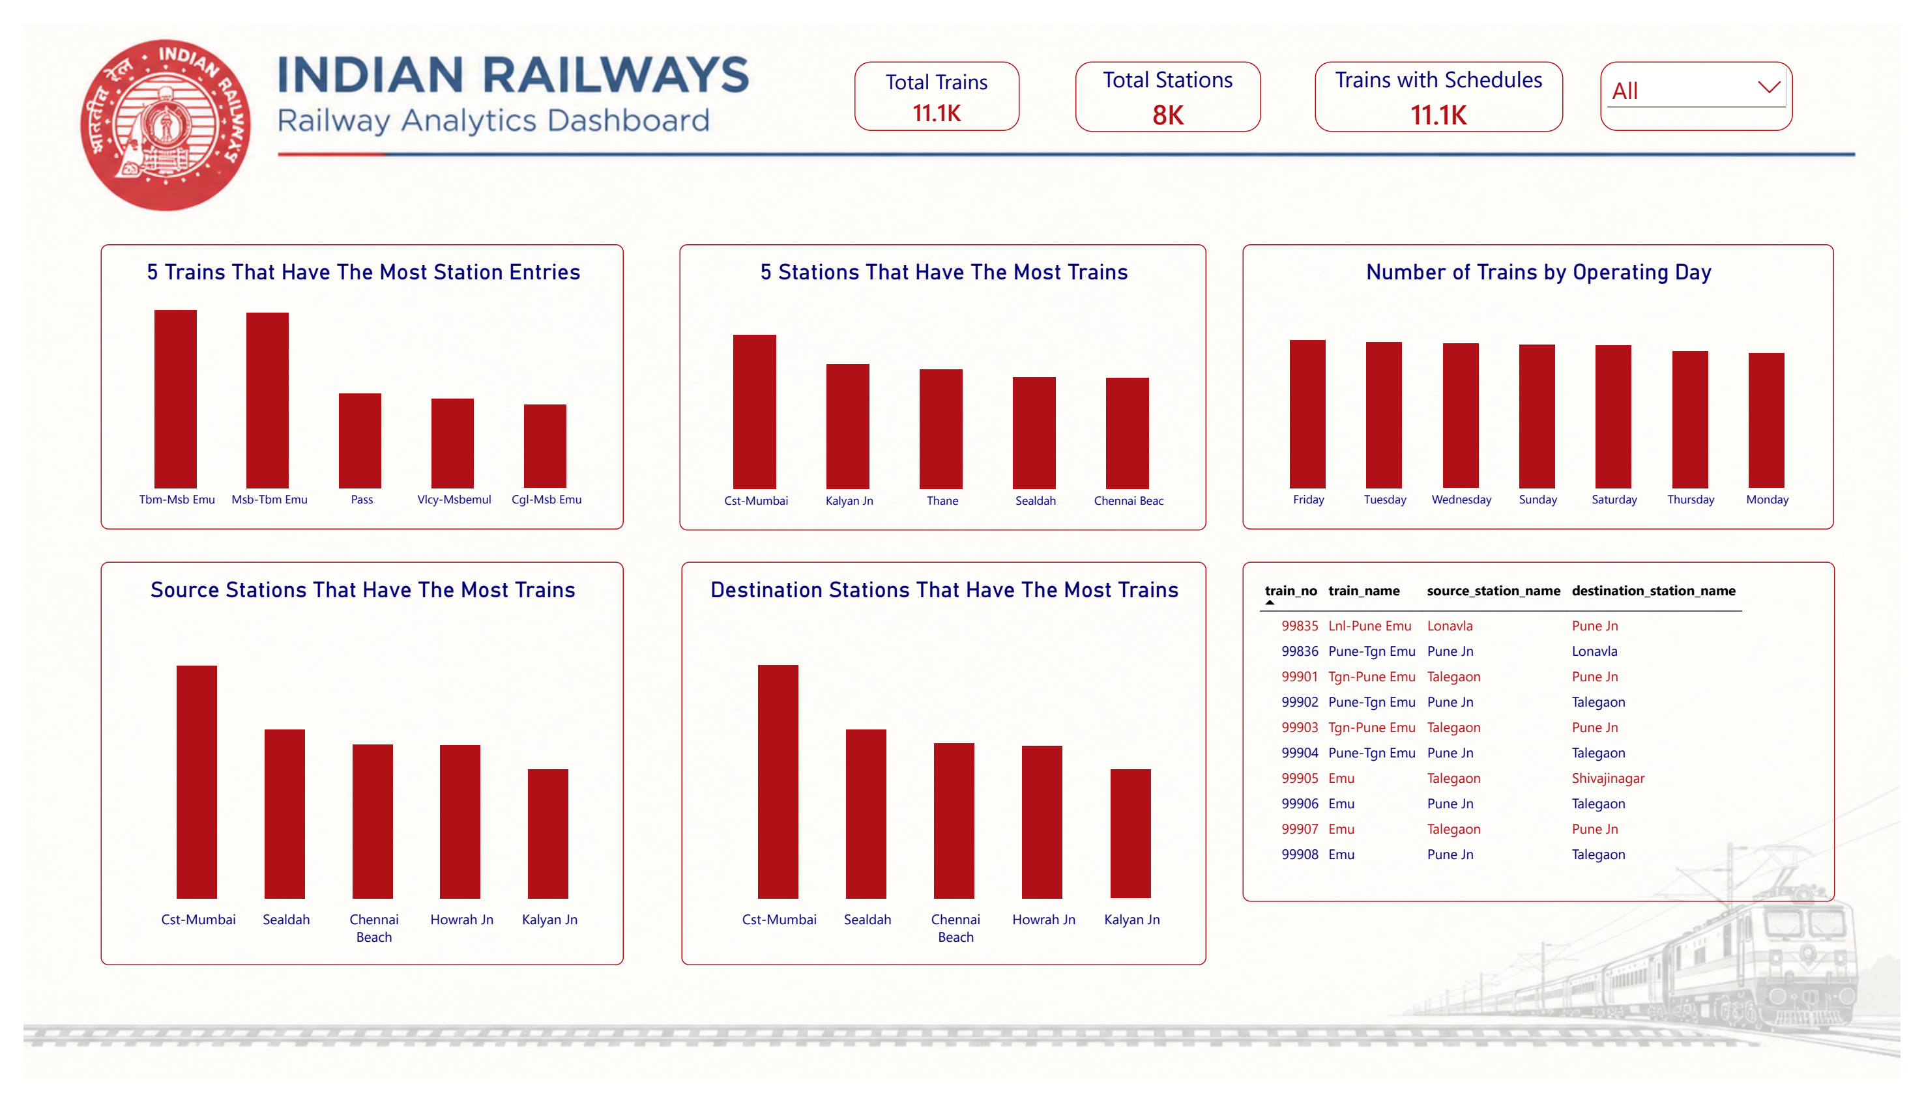
Figure 1 Existing Dashboard.pdf export. The image records the current dashboard; the verified tables in this report use the KPI definitions from the practice brief.
The dashboard provides three headline cards, train and station rankings, operating day counts, source and destination rankings, a train detail table, and a day slicer. The PDF displays 11.1K trains, 8K stations, and 11.1K trains with schedules. Rounded cards should be supplemented with exact values for validation.
The top-train visual uses train_name as its category and an aggregation of train_no from train_info. Because names repeat, it ranks name groups rather than schedule rows per train. Rebuild it with Train_No and Train_Name and a count of rows from train_schedule. Use Station_Code for station counts; the raw files contain 8,099 distinct station names versus 8,147 codes.

SQL review and recommended corrections
SqlAnalysis.sql includes useful joins and grouped counts, but several queries need changes to match the business definitions. The source SQL and Power BI files remain unchanged; the corrections below describe follow-up work.

Count trains by identifier
Question 1 counts distinct train names. Replace this with COUNT(DISTINCT train_no), which returns 11,113 rather than counting shared display names. The total-trains KPI currently uses an inner join; count the master directly so it remains correct if schedules are missing in a later dataset.

Count stations by code
Question 2 counts station names. Use COUNT(DISTINCT station_code) from train_schedule for the required station KPI. Station names can be shared, abbreviated, or inconsistent.

Check missing details from the schedule side
The KPI for schedule trains missing details starts from train_info and checks its own key for null; Question 5 only checks whether schedule train numbers are null. Neither tests unmatched schedule identifiers. Use the following anti-join; the verified result for these files is zero.
SELECT COUNT(DISTINCT s.train_no) AS missing_details
FROM train_schedule s
LEFT JOIN train_info i ON s.train_no = i.train_no
WHERE i.train_no IS NULL;

Keep individual trains separate
Question 6 groups only by train_name, combining different train numbers with the same label. Group by i.train_no and i.train_name. Question 7 already uses both fields and counts schedule rows, which is the appropriate basis for the top-five train table.

Use explicit dashboard counting rules
Total trains should use distinct train numbers from the master. Trains with schedules should count matched distinct identifiers. Trains per station should count distinct train numbers for each station code. Station entries per train should count schedule rows. Validate these values after applying the day slicer and after every refresh.

Recommended priorities
First correct identifier-based counts and unmatched-record checks. Then rebuild the top-train visual and reconcile station labels. Finally add repeatable quality checks and preserve identifier types and stop sequences so future refreshes remain comparable.

Reproduction and project conclusions

How to reproduce the workflow
- Install Python with Jupyter, pandas, NumPy, matplotlib, seaborn, SQLAlchemy, and PyMySQL. MySQL and Power BI Desktop are required for the full workflow. Package versions are not pinned in the project.
- Open indian_railway.ipynb with the project folder as the working directory. Review the transformation cells and update the local database connection. Keep connection credentials outside version-controlled notebooks.
- Create the indian_railways_db database and review the replace-table behavior before running the database export cells. Resolve the string-replacement portability issue and preserve identifiers as text.
- Run SqlAnalysis.sql against the loaded tables, applying the query corrections described in this report. Compare the outputs with the verified KPI table.
- Open Visualization.pbix in Power BI Desktop, update the MySQL connection settings, check the Train_No relationship and counting rules, and refresh. Compare unfiltered results and test the operating day slicer. Dashboard.pdf is the static viewing alternative.

Limitations
The dataset has no documented observation period or source provenance in the project materials. Results therefore describe the supplied snapshot, not the current Indian Railways network. The days column contains a single label per train and does not prove weekly operating frequency. Distance units and class-column semantics must be verified before financial or route-length analysis.
No live MySQL execution or Power BI refresh was performed for this report. CSV results, saved notebook outputs, SQL text, the dashboard PDF, and report visual definitions were reviewed. The report does not certify the current database state or interactive filter behavior.

Conclusion
The project demonstrates an end-to-end descriptive analytics workflow from CSV preparation through SQL to dashboard presentation. Complete train-number matching supports the relationship between the two datasets. The next improvement is analytical consistency: count identifiers, keep train-level and name-level groups separate, and validate each visual against a documented KPI definition.

Project evidence
Business scope and definitions: Railway_Analytics_Practice.docx. Data and verified results: train_info.csv and train_schedule.csv. Implemented preparation and loading: indian_railway.ipynb. Query review: SqlAnalysis.sql. Presentation review: Visualization.pbix and Dashboard.pdf. Report preparation date: 9 October 2026.

